31. Write a Python program to create a stacked bar plot with error bars.  
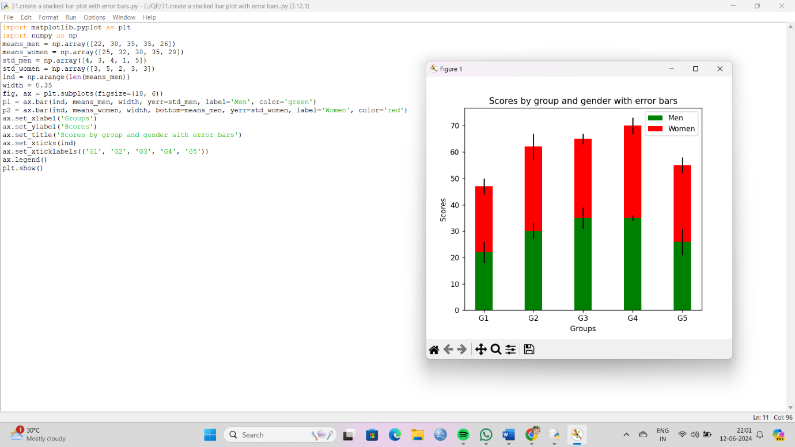

32. Write a Python program to draw a scatter graph taking a random distribution in X and Y and plotted against each other.

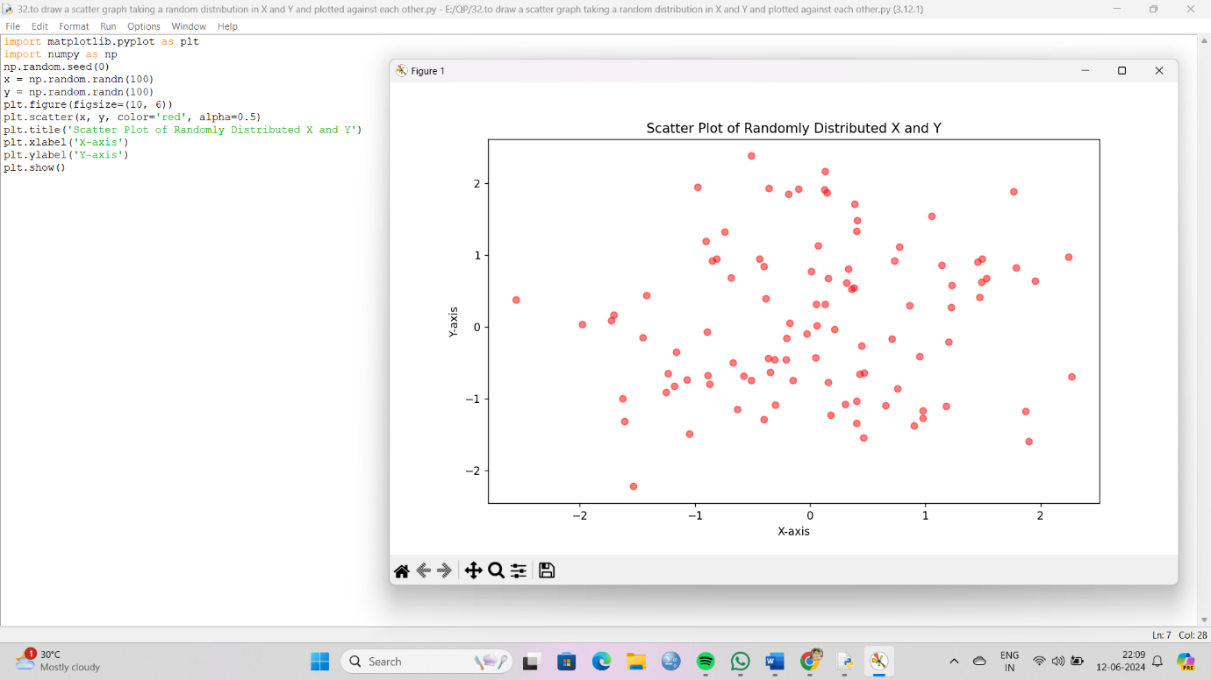

33. Write a Python program to draw a scatter plot with empty circles taking a random distribution in X and Y and plotted against each other.

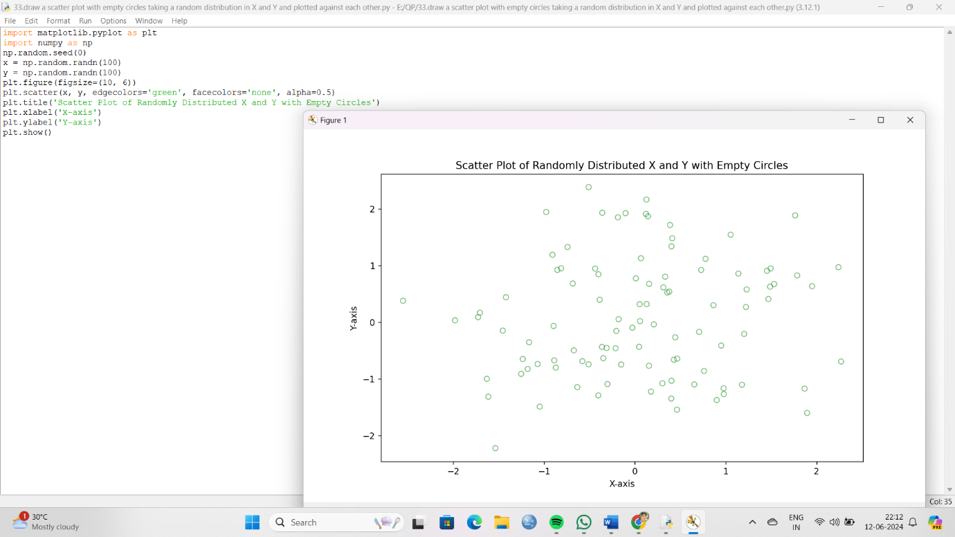

34. Write a Python program to draw a scatter plot using random distributions to generate balls of different sizes.

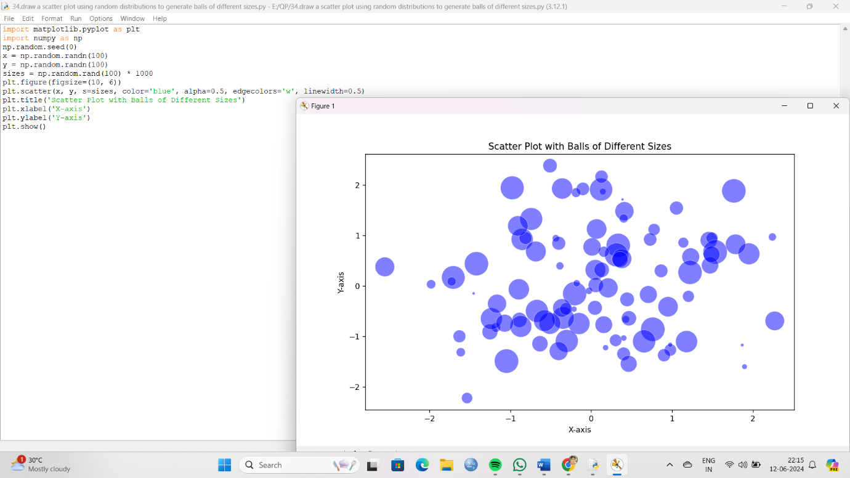

35. Write a Python program to draw a scatter plot comparing two subject marks of Mathematics and Science. Use marks of 10 students.

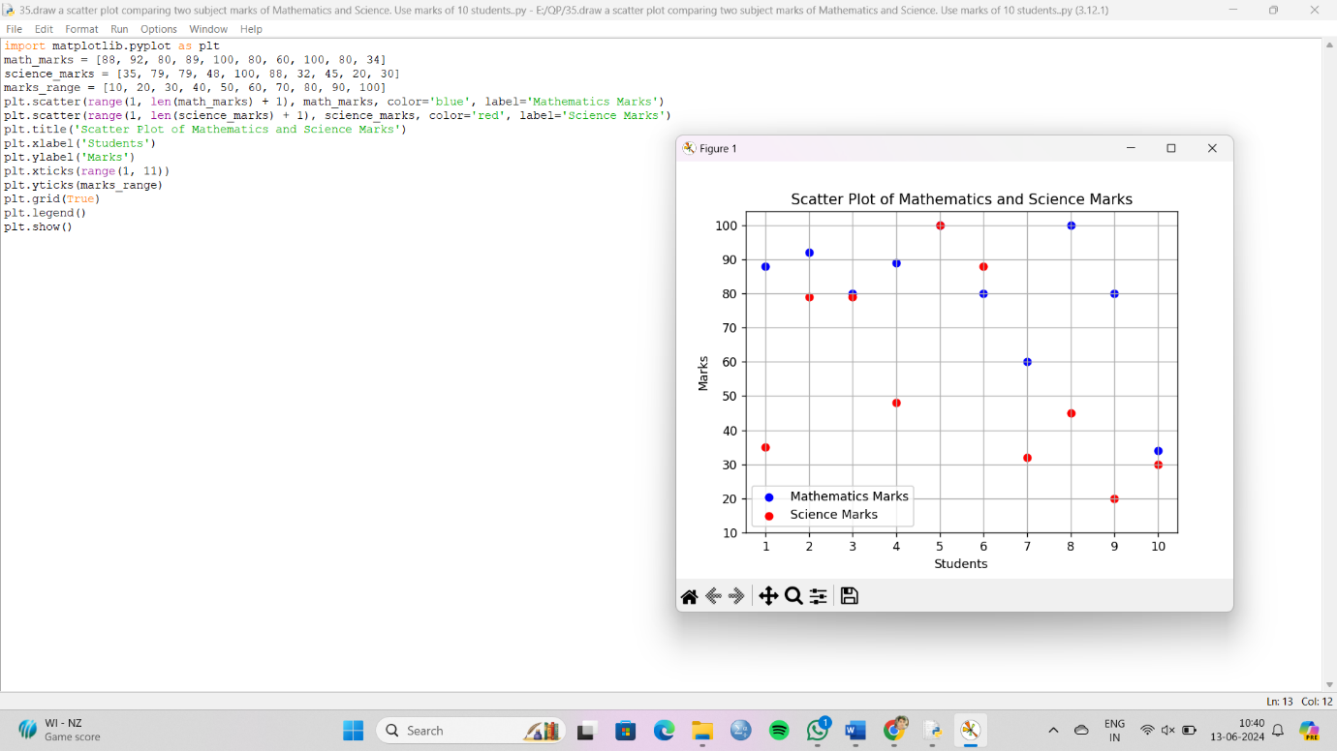

36. Write a Python program to draw a scatter plot for three different groups comparing weights and heights.

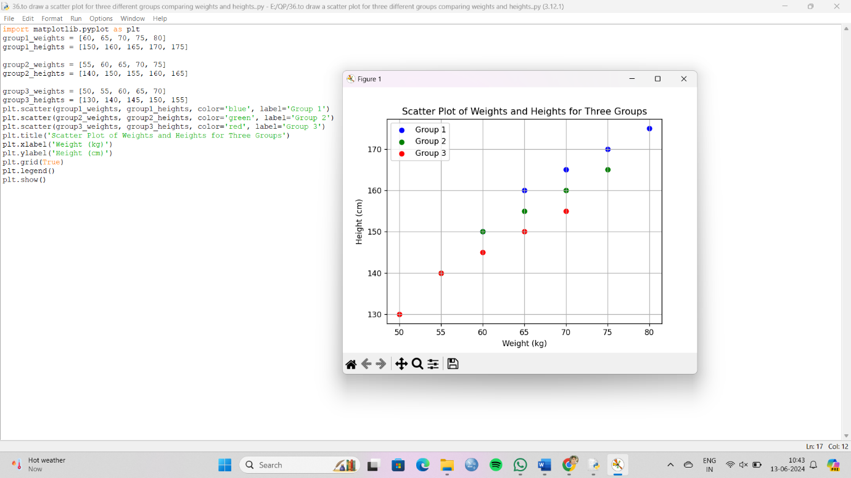

37.Write a Pandas program to create a dataframe from a dictionary and display it.  
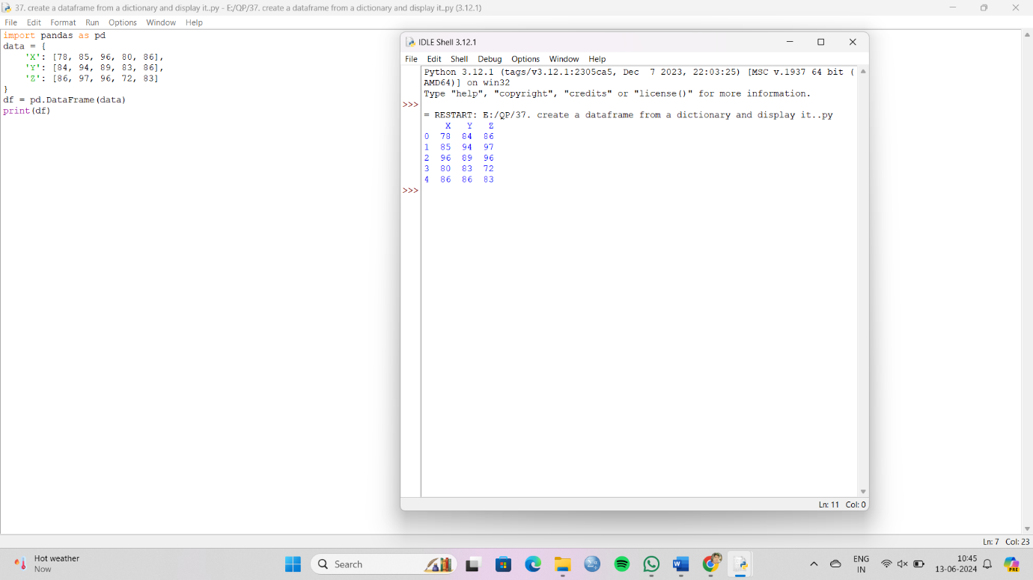

38. Write a Pandas program to create and display a DataFrame from a specified dictionary data which has the index labels.

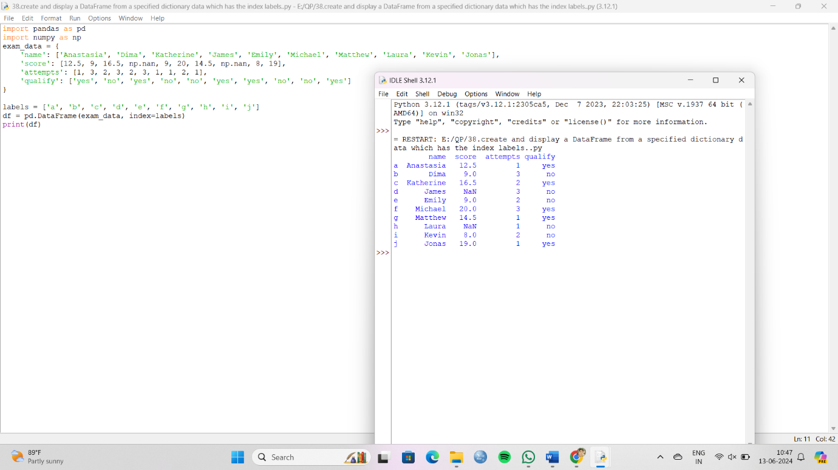

39. Write a Pandas program to get the first 3 rows of a given DataFrame.  
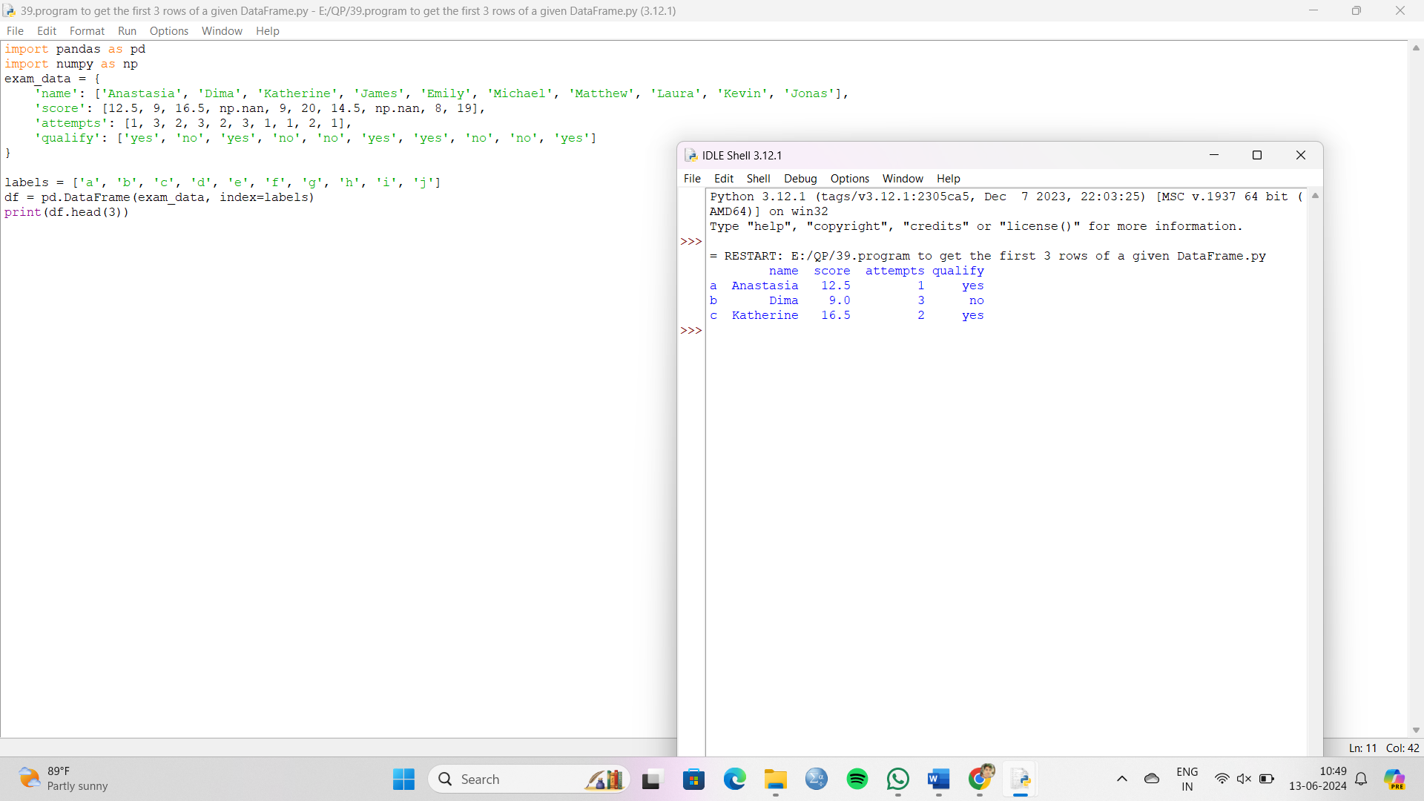

40. Write a Pandas program to select the 'name' and 'score' columns from the following DataFrame

